
DBMS PROJECT
Restaurant Database Management system

Presented by:
Shalmali Vyavahare 1262250211
Tanvi Patil 1262250431
Keyura Sangeria 1262250647
Somya Bhargava 1262250200

Guided by -Sagar Apune

ABSTRACT
The Restaurant Management System is a database management system designed to simplify and organize the daily operations of a restaurant. The system maintains essential information related to customers, food menu items, orders, order details, payments, and employees. It uses a relational database to store and manage data efficiently, reducing manual effort and minimizing data duplication.
The system is developed using SQL and incorporates important DBMS concepts such as table creation, primary keys, foreign keys, data manipulation, and relational queries. The relationships between tables help maintain data consistency and integrity. SQL queries can be used to retrieve customer and order information, display menu details, and calculate the total bill for each order. The system also supports the organized storage of payment records and employee information.
The main objective of this project is to provide a structured and reliable method for managing restaurant data. By organizing information into related tables, the system makes data retrieval easier and improves the management of restaurant records. This project demonstrates the practical application of relational database concepts and SQL operations in a real-world scenario. It can be further enhanced with features such as a graphical user interface, inventory tracking, online ordering, and sales reporting.

INTRODUCTION
A Restaurant Management System is a database-based application designed to organize and manage the day-to-day activities of a restaurant. Restaurants handle various types of information, including customer details, food menu items, orders, payments, and employee records. Managing this information manually can be time-consuming and may lead to errors, data duplication, and difficulties in retrieving records.
The proposed Restaurant Management System uses a Relational Database Management System (RDBMS) to store and manage restaurant information systematically. The database consists of related tables such as Customer, Menu, Orders, OrderDetails, Payment, and Employee. Each table stores specific information, while primary keys and foreign keys establish relationships between tables and help maintain data integrity.
SQL (Structured Query Language) is used to create tables, insert records, update information, retrieve data, and perform operations such as joining tables and calculating order totals. These operations demonstrate the practical application of DBMS concepts in a real-world scenario.
The main aim of this project is to simplify restaurant data management, improve the accuracy of stored information, and make data retrieval more efficient. The system also provides a foundation for future enhancements, such as inventory management, online ordering, graphical user interfaces, and sales report generation.
Through this project, important database concepts, including relational tables, keys, constraints, and SQL queries, are applied to develop a structured solution for restaurant operations.

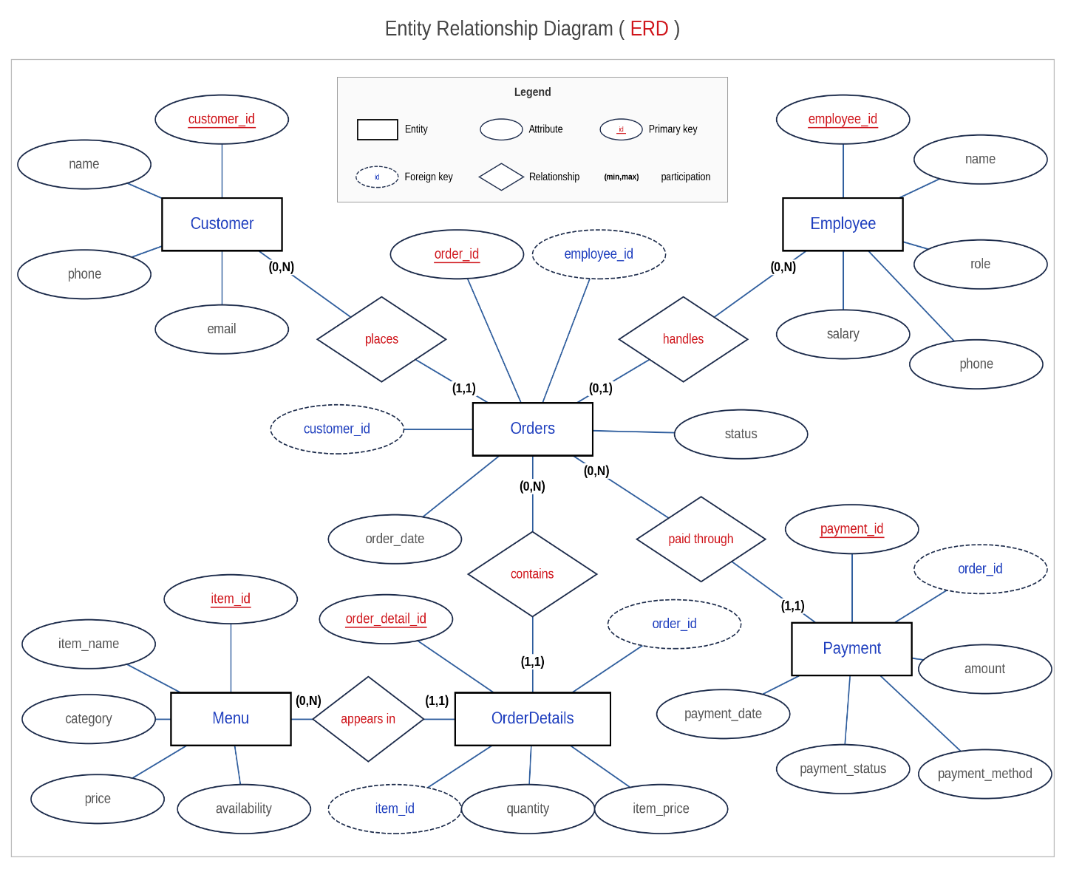

Table Schema
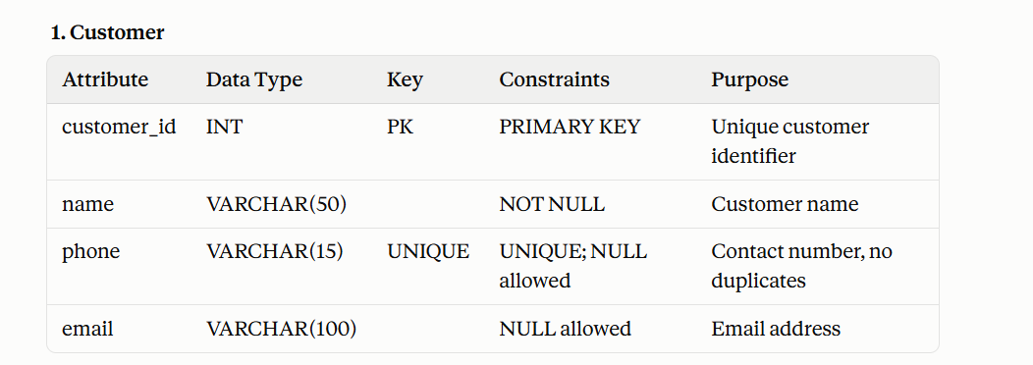
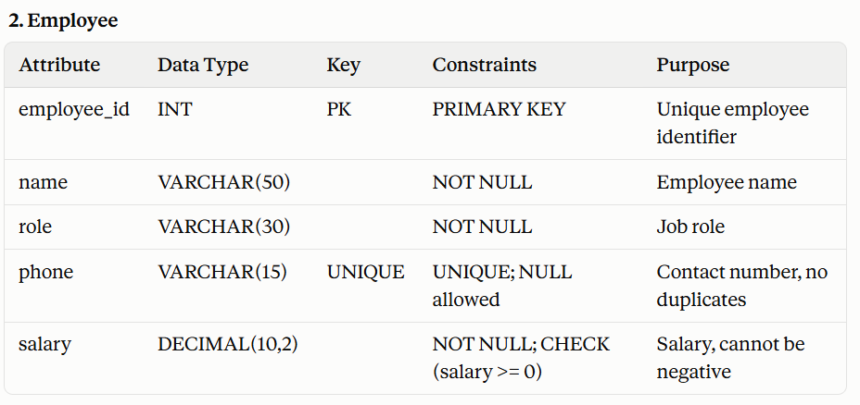
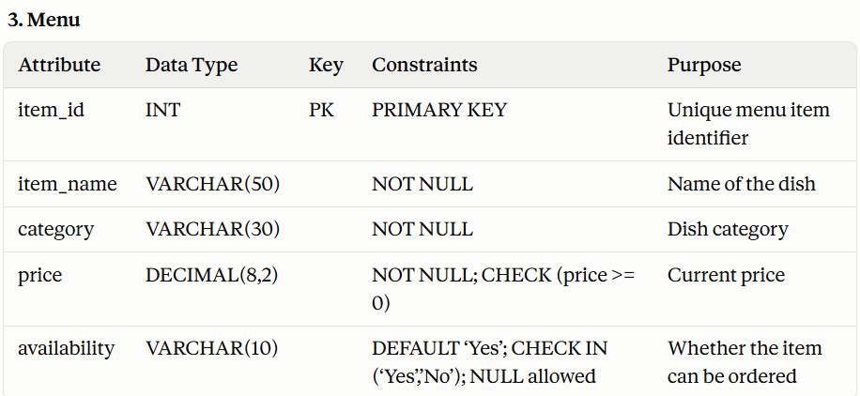

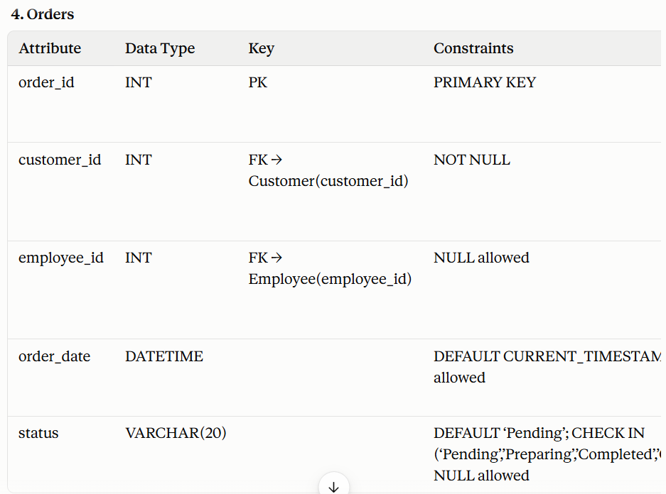
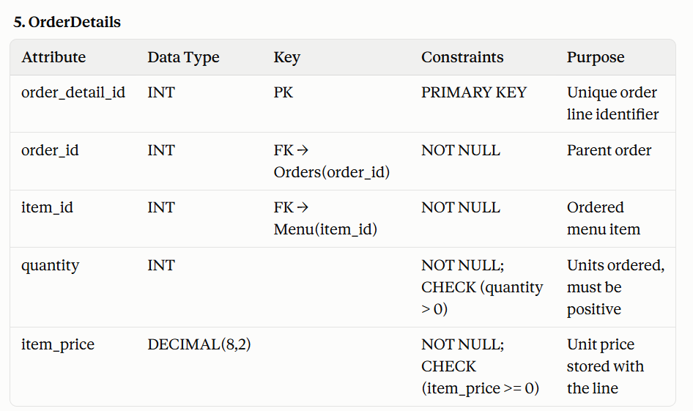

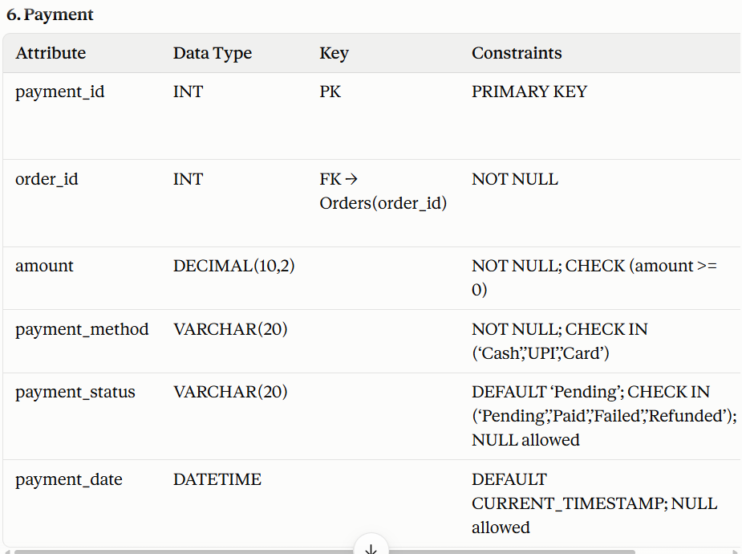
APPLICATION
The Restaurant Management System can be used to manage and organize the essential operations of a restaurant through a relational database. It provides a structured way to store, update, and retrieve information related to customers, food items, orders, payments, and employees.
The major applications of the system are as follows:
1. Customer Management
The system stores customer details, including customer ID, name, and phone number. This information can be retrieved whenever required and associated with the customer's orders.
2. Menu Management
The system maintains food menu details, including item ID, item name, category, price, and availability. This helps organize menu information and retrieve the details of available food items.
3. Order Management
The system records customer orders, including order ID, customer ID, order date, and order status. It helps maintain order records and establish relationships between customers and their orders.
4. Order Details Management
The OrderDetails table stores the food items included in each order, along with their quantities and item prices. This allows multiple food items to be associated with a single order.
5. Billing and Payment Management
The system stores payment details, including payment ID, order ID, amount, payment method, and payment status. SQL aggregate functions can be used to calculate the total bill for an order based on item quantities and prices.
6. Employee Management
The system maintains employee information, such as employee ID, name, role, phone number, and salary. This helps organize employee records in a centralized database.
7. Data Retrieval and Reporting
SQL queries and joins can be used to retrieve related information from multiple tables, such as customer names with their orders. Aggregate functions can also help calculate order totals and generate basic reports from the stored data.
8. Data Integrity and Consistency
Primary keys and foreign keys help uniquely identify records and maintain relationships between tables. These constraints reduce data inconsistencies and help ensure that related records refer to valid entries.
Overall, the Restaurant Management System demonstrates how an RDBMS can be applied to organize restaurant information, simplify record management, and retrieve relevant data efficiently. The system can be extended in the future with inventory tracking, online ordering, and graphical user interface features.

FUTURE IMPROVEMENTS
The Restaurant Management System provides a foundation for managing restaurant data using a relational database. However, several additional features can be implemented in the future to improve its functionality, efficiency, and user experience.
1. Graphical User Interface (GUI)
A user-friendly graphical interface can be developed to allow restaurant staff to manage customers, menu items, orders, and payments without directly writing SQL queries.
2. Inventory Management
An inventory module can be added to track the availability of ingredients and other restaurant supplies. Stock levels can be updated automatically when ingredients are used, and alerts can be generated when stock is low.
3. Online Ordering System
The system can be extended to support online food ordering, allowing customers to browse the menu, select items, place orders, and view their order status.
4. Automated Billing
A billing module can be developed to calculate the total amount, apply taxes and discounts, and generate digital bills or receipts automatically.
5. Sales Reports and Analytics
Reporting features can be added to analyze daily, weekly, and monthly sales, identify popular food items, and help restaurant owners make better business decisions.
6. User Authentication and Security
Login functionality and role-based access can be introduced for administrators, managers, and restaurant staff. This would help protect sensitive information and restrict access to authorized users.
7. Table Reservation Management
A reservation module can be implemented to allow customers or staff to book tables in advance and manage table availability.
8. Backup and Recovery
Automated database backups and recovery mechanisms can be introduced to protect restaurant records against accidental deletion, system failures, and data loss.
In conclusion, these improvements can transform the basic database system into a more comprehensive restaurant management application. They can enhance convenience, improve operational efficiency, and support the future growth of the restaurant.

CONCLUSION
The Restaurant Management System demonstrates the practical application of Database Management System (DBMS) concepts in managing restaurant operations. The project provides a structured approach to storing and organizing information related to customers, menu items, orders, order details, payments, and employees using a relational database.
By using SQL, the system supports database operations such as creating tables, inserting records, updating information, and retrieving data through queries. The use of primary keys and foreign keys helps establish relationships between tables and maintain data integrity. SQL joins and aggregate functions can also be used to retrieve related information and calculate order totals.
This project helped in understanding the importance of relational database design, data organization, and efficient information retrieval in a real-world application. It also provided practical experience in implementing SQL queries and applying fundamental DBMS concepts.
Although the current system focuses on database-level operations, it can be enhanced in the future by introducing a graphical user interface, inventory management, online ordering, automated billing, and sales reporting. Overall, the project provides a foundation for developing a more comprehensive restaurant management application and demonstrates how DBMS technology can simplify data management and improve operational efficiency.

References
1. ElvaShen / Restaurant_Management_Database_Design (GitHub)
https://github.com/ElvaShen/Restaurant_Management_Database_Design/blob/master/README.md
- What it describes: a complete restaurant database that covers reservations, orders, menus, inventory, revenue, customer reviews, employees and suppliers.
- Design process: it lays out the steps in order: conceptual design with ER diagrams, business rules, conversion to Third Normal Form (3NF) with keys, physical design, then SQL implementation with indexing.
- Reporting queries: it mentions daily revenue, daily cost and total sales per item.
- Use it for: your Introduction and Objectives, the normalization discussion, and Future Improvements ideas such as inventory, suppliers and reviews.

3. Medium: From Design to Deployment, SQL Database Project Lifecycle
https://medium.com/@zuhalA/from-design-to-deployment-sql-database-project-lifecycle-fbda96c6d8e5
- What it describes: how to build a database for a small fast-food restaurant, from requirements to deployment.
- Tables: Orders, Menu Items, Ingredients, Recipes and Inventory.
- Steps: it covers the ER diagram, the schema design, and creating the database on a MySQL server. It names QuickDBD and MySQL Workbench as design tools.
- Use it for: the order in which a project is built, adding ingredient and inventory tracking, and a tool for drawing a crow’s-foot diagram.
4. cgoncalves94 / CS-103-Databases (GitHub)
https://github.com/cgoncalves94/CS-103-Databases
- What it describes: a PostgreSQL database for a restaurant menu, covering dishes, drinks and their ingredients.
- Material provided: an ER diagram, and separate files for the schema, the sample data inserts and the queries.
- Use it for: a menu-to-ingredient design, and how to organise a project into schema.sql, insert_data.sql and queries.sql. It uses PostgreSQL, so its syntax differs from your MySQL code.
5. Coursework: Fast-food restaurant management system (Scribd)
https://www.scribd.com/document/656474800/Course-Work-Final
- What it describes: a student report for a fast-food restaurant database. Its contents list includes an ER diagram, SQL constraints, queries, subqueries, a procedure, a trigger, views and an index.
- Use it for: the layout of a full DBMS report, which is the closest to what you are writing. Scribd may require a sign-in.

Snapshot for execution

